

Bravilor Novo Pour & Serve De-scale Instructions

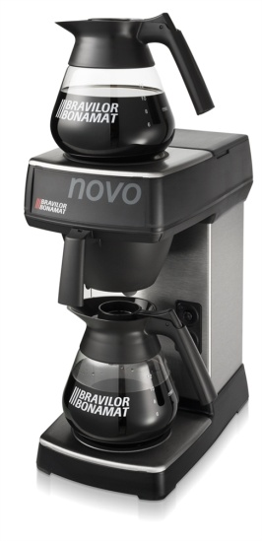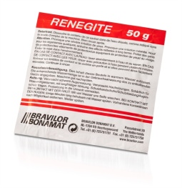
- Slide the empty filter pan into place with and place an empty glass decanter below.
- Empty one sachet of 50g Renegite De-scaler into the other decanter and fill it with hot water to just under the black rim and stir to ensure all the crystals have been fully dissolved.
- Empty the Renegite solution into the machine through the lid located on the top of the machine.
- Allow the machine to sit for 45 minutes for the de-scale solution to remove any traces of scale from within the internal boiler and for the temperature of the de-scale solution to drop. Running the percolation process when the water poured into the tank is already at a hot temperature can result in steam or spitting of water. Ensure the glass decanter is placed below the black plastic filter pan before you turn the machine on.
- If you are in no rush, allow the de-scale solution to remain in the boiler overnight and empty it in the morning. Our advice is to leave a note on the machine informing people to not to inadvertently use the machine during this time.
- I both cases, allow the machine to run its full cycle (6-7 minutes) until the glass decanter has been filled with the content of the boiler which can be emptied into a sink.
- Fill the glass decanter with 12 cups of clean cold water and pour into the machine placing the jug below to ensure the water will be collected as the cycle is repeated. This flush through process will ensure the removal of remaining de-scale residue.

This preventative process will maintain the performance of your Novo Pour & Serve Machine and ensure its longevity.

- Unless you live in an area of extremely soft water, a minimum of one sachet should be used every calendar month or every 50 sachets (the content of 1 standard Kingdom Coffee case of filter coffee).
Order code: 111-031 - Renegite 50g De-Scale Sachet

