

Marco Thermos Machine De-scale Instructions

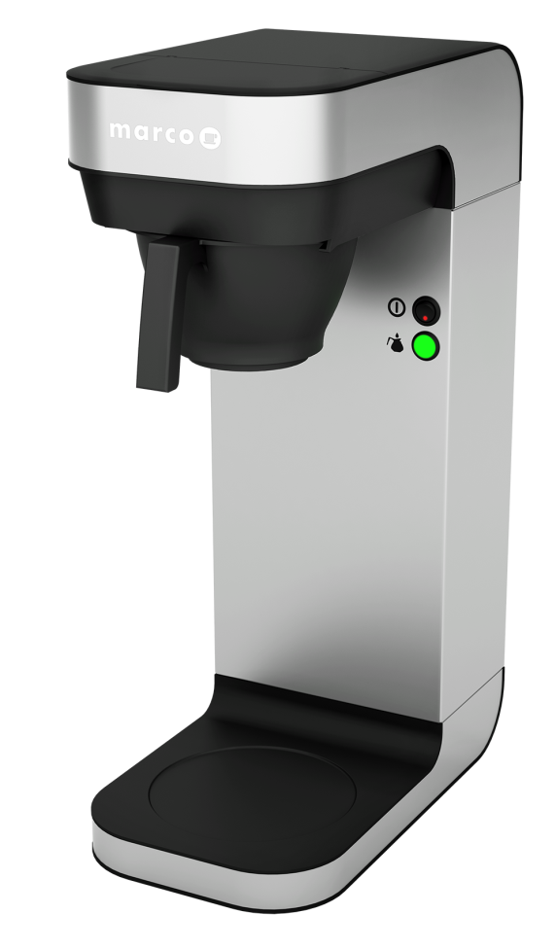

- Slide the black plastic filter pan into place (no filter paper required).
- Empty one sachet of 50g Renegite De-scaler into the 2.2 litre plastic jug of hot water and stir to ensure all the crystals have been fully dissolved.
- Empty the Renegite solution into the machine through the lid located on the top of the machine.
- Allow the machine to sit for 45 minutes for the de-scale solution to remove any traces of scale from within the internal boiler and for the temperature of the de-scale solution to drop. Running the percolation process when the water poured into the tank is already at a hot temperature can result in steam and the spitting of hot water. Ensure the clear plastic jug is placed below the black filter pan prior to turning on the machine.
- If you are in no rush and for the best results, allow the de-scale solution to remain within the boiler overnight and run it through in the morning. Our advice is to leave a note on the machine informing people to not to use the machine during this time.
- Turn the machine on and allow it to run its full cycle (6-7 minutes) until the plastic jug has been filled. Empty the jug and what remains in the machine’s boiler into a sink.
- Fill the jug with 2.2 litres of clean cold water and pour into the machine placing the jug below to ensure the water will be collected as the cycle is repeated. This flush through will ensure the removal of remaining de-scale residue.

This process should be undertaken on a regular basis as a preventative measure against the build- up of scale related material, regardless of your location and the hardness of your local water. This simple preventative process will maintain the performance of your Thermos Machine and ensure its longevity.

- Unless you live in an area of extremely soft water, a minimum of one sachet should be used every calendar month or every 50 sachets of coffee (the content of 1 standard Kingdom Coffee case of filter coffee).
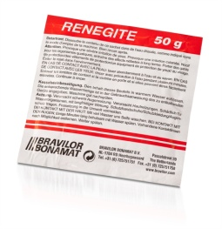 Order code: 111-031 - Renegite 50g De-Scale Sachet

