

Bravilor 75 Cup Percolator Cleaning Instructions

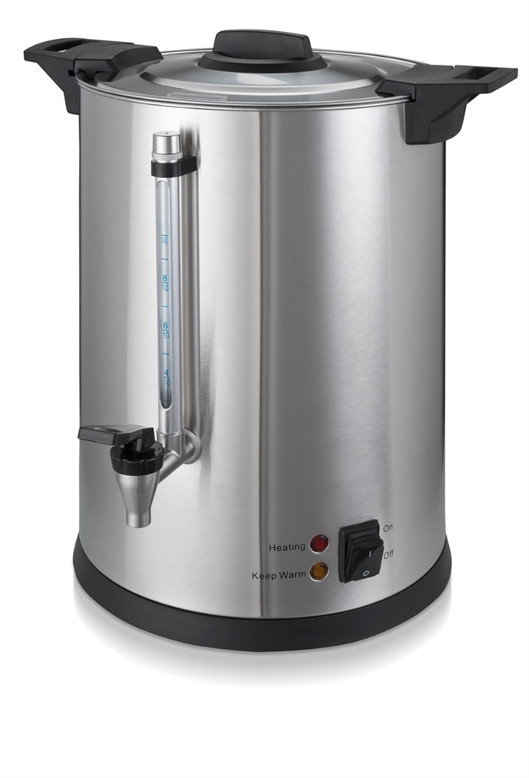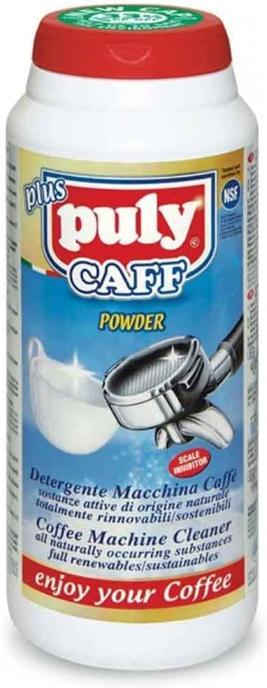
- Fill the percolator with 3 to 4 inches of clean water and add/sprinkle approximately 1 heaped tablespoon of Puly Caff Cleaning powder.
- Insert the central tube and metal filter pan and replace the lid.
- Power up the machine in the same way you would when percolating the filter coffee and allow the machine to run for about 20-30 minutes.
- Turn off the machine, remove the lid, metal filter basket and central tube and rinse under the tap.
- Using a nylon headed cleaning brush like the one below, gently clean the walls of the hole central to the internal base in which the central tube rests. This will ensure that any build of coffee tanning is removed.

- Empty the percolator of the Puly Caff cleaning solution and rinse thoroughly with clean water.
- Cleaning the walls of the hole central to the internal base, which is essentially the heating element, will help maintain the performance of your percolator and the Puly Caff solution will clean all internal surfaces during the cleaning cycle.
- This is intended as preventative maintenance and will ensure your percolator is free of coffee tanning and performing as intended.
- If your percolator is used on a weekly basis, undertaking this process once a month is sufficient.
Order code: 222-005 - Puly Caff Cleaner 1 x 900g

